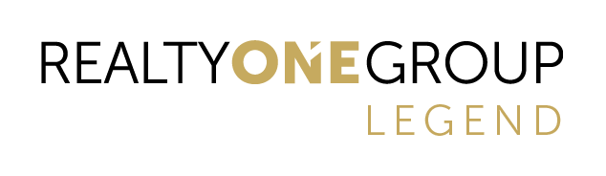
Agency Disclosure Form
Affiliated Business Agreement

Realty ONE Group Legend has an affiliation with the following agencies. In order to help facilitate a smooth transaction, you may want to give them the opportunity to provide you with a free, non-binding quote for the services they provide.

Golden Key Title

_______ YES, I would like Golden Key Title to provide the title commitment for the property I am purchasing.

_______ NO, I would not be interested in using Golden Key Title One for title services.

Name of Buyer: _______________________________________________________________________________________________

Property Address to be purchased: _________________________________________________________________________

_________________________________________________________________________

Cell Phone: ________________________________Email Address: ___________________________________________________

Buyer Signature Date

Buyer Signature Date

Agent Name: _________________________________ ___________________________

Agent Signature:

